Analysis of Five Real CBSE 2026 Papers — and the Solving Logic
I ran all five papers through extraction and measured what is actually in them. Everything below is a measured fact from your files, not an assumption. Several findings change the design.

1. What the five papers actually are
Paper | Code | PDF pages | Text layer | Questions | Structure
English (Lang. & Lit.) | 2/7/3 | 19 | Yes, clean | 11 | 3 sections: Reading (20) / Grammar & Creative Writing / Literature
Science (for V.I.) | 31(B) | 27 | Yes, English only | 39 | 3 sections: Biology (30) / Chemistry (25) / Physics (25)
Social Science | 32/7/1 | 27 | Partial, 22 images/page | 38 | 4 sections × 20 marks: History / Geography / Pol. Sci. / Economics
Hindi Course B | 4/8/3 | 16 | None — zero text on all 16 pages | — | Devanagari, image-only
Mathematics (Standard) | 30/7/1 | 7 | None — zero text, 85 images/page | — | 4-up imposed: 7 PDF pages = 27 logical pages

Finding 1 — two of five papers have no extractable text at all
Hindi and Maths are pure image PDFs. Any design that parses PDF text as the primary path fails on 40% of your subjects on day one. This validates the vision-first architecture and downgrades text parsing to an optimisation, used only when a text layer happens to exist.

Finding 2 — the Maths paper is 4-up imposed
Seven PDF pages carry twenty-seven logical A4 pages, tiled two-by-two, each tile with its own footer (30/7/1 Page 13 of 27), its own QR code, and dashed cut lines between them. A page-by-page extractor would produce four interleaved question streams and quadruple every question.
Fix: detect the imposition from the repeated footer pattern Page N of M appearing more than once per PDF page, split on the cut lines, and re-order by the printed logical page number before anything else runs.

Finding 3 — bilingual interleaving doubles everything
Science, Social Science, Maths and Hindi print every question twice — English and Hindi — usually on facing logical pages. Measured naive sums of every right-margin mark label:
Paper | Naive mark sum | Stated maximum | Excess
English | 90 | 80 | +12% (internal choice only)
Science | 172 | 80 | +115% (choice + bilingual)
Social Science | 349 | 80 | +336% (choice + bilingual + instruction numerals)

Without de-duplication and choice-grouping, the reconciliation gate would reject every real paper.

Finding 4 — marks are right-aligned at a fixed position
Across all three text-layer papers, the right edge of every bare mark label sits at x ≈ 0.88 × page width — the 10th, 50th and 90th percentiles are all 0.88. This is a typesetting rule, not a tendency.
Consequence: a mark-label candidate must be a bare integer, alone on its line, right-aligned in that band. This removes almost all false positives before a model reads anything, and it is the same geometric prior we apply to the answer script.

Finding 5 — the papers hand us four free verification equations
Every paper prints, in its General Instructions:
- Question count — "This question paper contains 38 questions."
- Section marks — "Each section carries 20 marks." / "Section A : Biology (30 marks)"
- Section arithmetic — the Maths paper prints the multiplication outright:
"This section has 5 Very Short Answer (VSA) type questions carrying 2 marks each. 5×2=10"
- Paper total — "Maximum Marks : 80"
These are exact, machine-checkable constraints. They are the question-paper equivalent of the cover total on an answer script, and they make extraction verifiable rather than merely probable.

Finding 6 — CBSE instructs the student to write the anchor for us
Every one of the five papers carries:
"Please write down the Serial Number of the question in the answer-book at the given place
before attempting it."
and, for Science and Social Science:
"Divide your answer sheet into sections as per the question paper... It is compulsory to answer
each question in its respective section. Do not mix answers of one section into the other section."
The anchor our localisation layer depends on is not something we hope to find — it is a field the board requires the student to fill in, in their own black or blue ink, in a designated place. And the section headers give us page-range priors for free.

Finding 7 — internal choice is everywhere, and it is not just a counting problem
Measured OR blocks: 6 in English, 9 in Science, 6 in Social Science. Two forms appear:
- whole-question choice — "16. (a) ... OR (b) ..."
- sub-part choice — "15. (iii)(a) ... OR (iii)(b) ..."
Both alternatives carry identical marks and contribute to the paper total once.

2. The consequence that changes the data model

The atomic unit is the address, not the question number
Marks are written per sub-part, not per question. English Q1 carries 10 marks spread across (i)–(x). Science Q15 carries 4 marks across (i), (ii) and (iii)(a)/(iii)(b).
So the Q-matrix key is:
SECTION / QUESTION_NO / SUB_PART / CHOICE_ALTERNATIVE
A / 15 / (iii) / b
B / 4 / (a) / -
Everything downstream — the solver, the mapping, the report — keys on this address. Keying on the bare question number does not survive contact with any of these five papers.

Choice creates missing-not-at-random data, and this is the important one
A student who attempts 16(b) has written nothing for 16(a). The naive system records 16(a) = 0.
That is wrong, and it is wrong in the direction that harms a child: it would systematically mark every student weak in whichever topic they chose to avoid, which is the opposite of the truth. The student produced no evidence about those skills, and no evidence is not weakness.
16(a) must be recorded as NOT OFFERED, excluded from the denominator, and reported as a coverage gap rather than a loss. This single rule is the difference between a diagnostic system and a misleading one.
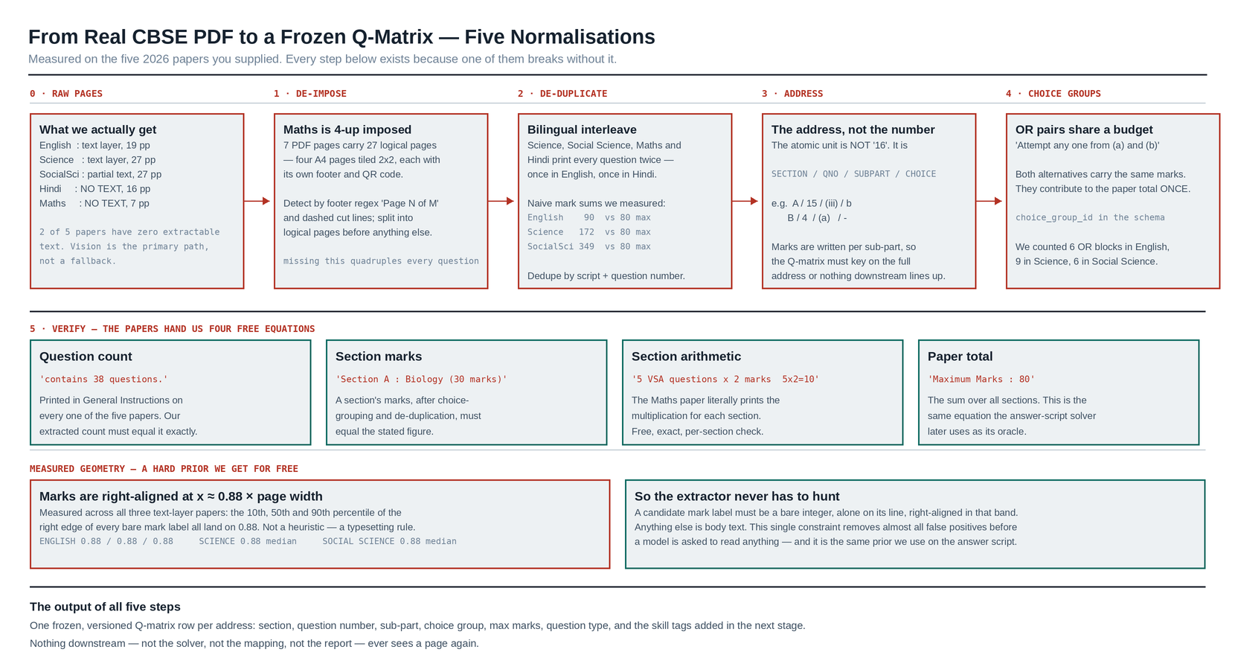
Figure A — the five normalisations that turn a real CBSE PDF into a frozen Q-matrix.

3. The solving pipeline, end to end
Stage A — Normalise the paper (once per paper)
- De-impose — detect repeated Page N of M footers per PDF page; split tiles; order by printed
logical page. (Maths needs this; the others pass through.)
- De-duplicate language — detect script per block (Latin vs Devanagari); keep the English
stream as canonical, attach the Hindi text as a translation of the same address. Never create two Q-matrix rows.
- Segment sections — from the section headers and the General Instructions block, which state
the section names and their marks.
- Extract addresses — question number, sub-part, choice alternative, with marks taken from the
right-aligned 0.88 band.
- Group choices — an OR line between two alternatives at the same address level creates a
choice_group_id; the group contributes its marks once.
- Verify — question count, per-section marks, section arithmetic, paper total. Any failure
blocks the paper and shows the teacher exactly which equation broke.
Stage B — Classify (once per paper, teacher-confirmed)
Each address gets: question type, skill tags, cognitive tier.
Question type is extracted, not guessed — the instructions state the marks and word limits for each type. All eight of these appear in your papers:
MCQ · Assertion–Reason · Match-the-columns · VSA (2 marks, 40 words) · SA (3 marks, 60 words) · LA (5 marks, 120 words) · Case-based CBQ (4 marks, 3 sub-parts) · Map work (2 + 3 marks)
Stage C — Map the answer sheet (per student)
- Colour separation: teacher's red mark layer, student's black/blue layer.
- Anchors from the student layer — the serial numbers CBSE required them to write.
- Normalise the written address (strip punctuation, map Devanagari numerals, fold script variants).
- Closed vocabulary — the parsed address must exist in the frozen Q-matrix. 16(c) does not
exist on this paper, so it is rejected rather than invented.
- Section prior — a page inside the Geography block resolves an ambiguous "4" to B/4, not A/4.
- Marks from the teacher layer; Hungarian association; convention refit; constraint solve
against section and paper totals.
- Choice resolution — for each choice group, the attempted alternative takes the mark; the other is
recorded NOT OFFERED.
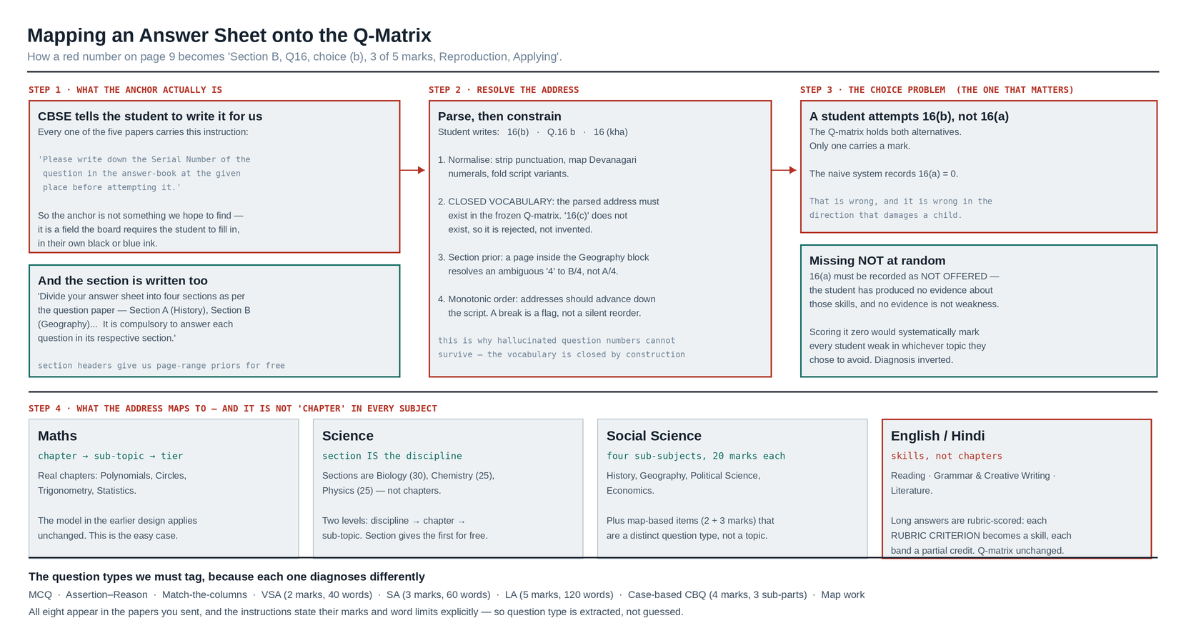
Figure B — mapping an answer sheet onto the Q-matrix, including the choice problem.

4. What "chapter" means is different in every subject
This is the finding that most affects the taxonomy work, and it is why the subject pack has to be data rather than code.
Subject | First level | Second level | Notes
Mathematics | Chapter (Polynomials, Circles, Trigonometry, Statistics…) | Sub-topic | The straightforward case; the original design applies unchanged.
Science | The section *is* the discipline — Biology (30), Chemistry (25), Physics (25) | Chapter → sub-topic | Section gives the first level for free, with no classification needed.
Social Science | Four sub-subjects, 20 marks each — History, Geography, Political Science, Economics | Chapter → sub-topic | Plus map work as a distinct question type, not a topic.
English / Hindi | Skills, not chapters — Reading, Grammar & Creative Writing, Literature | Sub-skill | Long answers are rubric-scored: each rubric criterion becomes a skill, each band a partial credit. The Q-matrix formalism absorbs this unchanged.

For English and Hindi, "which chapter is the student weak in" is not a meaningful question. The meaningful one is "is the gap in inference from a passage, in grammar accuracy, or in structuring a formal letter" — and that is exactly what a skill-based Q-matrix gives you.

5. Difficulty ranking — where to start
Rank | Subject | Why
1 — easiest | English | Clean text layer, single language, only 11 questions, sections carry explicit marks. Best first target for the pipeline.
2 | Science | Text layer, section = discipline, well-formed question types, clear internal choice.
3 | Social Science | Partial text, image-heavy, four sub-subjects, map questions need special handling.
4 | Maths | No text layer, 4-up imposition, and mathematical notation in the stems.
5 — hardest | Hindi | No text layer, Devanagari handwriting and print, and rubric-scored long answers.

Recommendation: build and prove the pipeline on English and Science first. They exercise every mechanism — sections, sub-parts, internal choice, multiple question types, the verification equations — without also fighting imposition and Devanagari OCR. Maths and Hindi then need only the two extra front-end steps (de-imposition, Devanagari normalisation), not a new pipeline.

6. What this analysis changes in the plan
- Vision-first is confirmed, not a preference. Two of five papers have no text at all.
- Add a de-imposition step to Stage A. It was not in the earlier plan and Maths needs it.
- Add language de-duplication to Stage A. Without it, every gate fails on four of five papers.
- Change the Q-matrix key from question number to the full address. This is a schema change and
it should land before any extraction code is written.
- Add `NOT OFFERED` as a first-class mark state, distinct from zero and from absent. Three
states, not two.
- English and Hindi need a skills taxonomy plus rubric criteria, not a chapter list. That is
taxonomy authoring work that can start immediately, in a spreadsheet, in parallel with the build.
- Extract the General Instructions block as structured data. It contains the question count,
the section marks, the question types and their word limits — the verification equations are printed on page 1 of every paper, and we should be reading them.

